PureExo® **Exosome Isolation kit** (for serum or plasma)

**Cat. #:** P101 (10 reactions); P101L (40 reactions); P101S (2 reactions)

**Storage**: keep all bottles upright, in cool and dark place. **Shelf Life:** 12 months

**Product Size:**   Each reaction can process 100-500 μL serum or plasma. The yield of each reaction is 100-200 μL exosome, from which 300-400 μg exosomal protein or 200-300 ng exosomal RNA can be extracted..

**Product Description** (This product is for research use only.)

This kit can isolate / purify pure exosome at high yield from serum or plasma.

* Easy to use: No ultra-centrifugation (< 2 hours)
* 10 fold higher yield (vs. other kits and ultracentrifuge)
* Save cost (vs. antibodies-beads method)
* Isolate Pure exosome (>95%)
* Intact exosome (good morphology)

Use as little as 100 µL serum to achieve high yield of exosomes for any downstream applications: EM study, exosome label, exosome subpopulation, qRT-PCR profiling of exosomal miRNAs, and gel analysis of exosomal proteins.

**Product Contents** (store in room temperature)

|  |  |  |  |
| --- | --- | --- | --- |
| **Component** | **Amount** | | |
| Cat. #: **P101** | Cat. #: **P101L** | Cat. #: **P101S** |
| Solution A | 2.5 mL | 10 mL | 0.5 mL |
| Solution B | 2.5 mL | 10 mL | 0.5 mL |
| Solution C | 2.5 mL | 10 mL | 0.5 mL |
| Sample Buffer | 20 mL | 80 mL | 4 mL |
| PureExo® Column | 10 | 40 | 2 |

***\**** *Tightly cap all bottles immediately after each use to prevent evaporation.*

**Do not process more than** **500 µL serum or plasma** for each reaction. Otherwise it will cause indistinct layer separation and column clogging.

**Protocol** (for processing 100-500 µL serum / plasma)

1. Collect 100-500 μL serum or plasma sample and keep it on ice. If start with frozen sample, thaw the sample completely at room temperature, and keep it on ice. (For serum / plasma preparation, please refer to the instruction: <http://www.101bio.com/files/P101_serum_plasma_prep.pdf> ).
2. Centrifuge the serum / plasma sample at **3,000× g** for **15 minutes** at **4oC** to remove debris.

* **Important**: Skipping this step may cause filter clogging in step 17.

1. Transfer **100-500 μL** clear supernatant to a **15 mL centrifuge tube** without disturbing the pellet. Add **Sample Buffer** to the supernatant to make a total volume of **2 mL diluted serum/plasma sample**, and keep it on ice. This dilution works well for all starting samples of 100 to 500 μL. **Do not process more than 500 μL sample per reaction**.
2. In **a 1.5 mL microcentrifuge** **tube**, add Solution A, B and C in the following order to prepare 0.75 mL mixture A/B/C (always prepare this mixture A/B/C right before use):

**1st** add Solution A: 0.25mL **2nd** add Solution B: 0.25mL **3rd** add Solution C: 0.25mL

***\**** *Cap all bottles well immediately after each use to prevent evaporation.*

1. **Vortex** themixture A/B/C for **10 seconds** to obtain a homogenous solution.
2. Add the 0.75 mL mixture A/B/C to the 2 mL diluted serum / plasma sample (from step 3).
3. Cap the 15 mL tube, vigorously vortex for **30 seconds**, then incubate at **4°C** for **30 minutes**.
4. 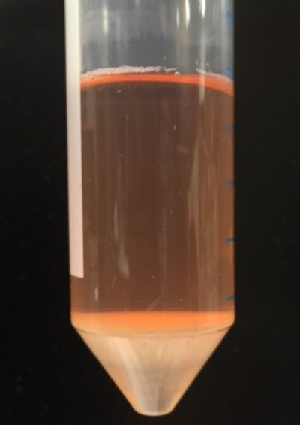Spin the tube at **5,000× g** **for 3 minutes**.
5. **a.** The mixture now appears as 3 sharp layers:

Bottom colorless layer

Top transparent layer

Middle fluffy layer (Exosome is in this layer.)

Without disturbing the Middle fluffy layer, go to step 10 (refer to step 9b only if 3 layers separation are not sharp).

 **b.** For some samples, layer separation is not sharp. You can vaguely see 3 layers (as shown in the figure below): Top cloudy layer (aqueous layer), middle fluffy layer (thicker and less transparent than top layer) and bottom colorless layer.

Top cloudy layer

Middle White cloudy layer

Bottom colorless layer

Carefully remove the top layer and discard it. Because the separation is not sharp, bey careful, not to disturb or remove the middle fluffy layer because exosome is in this layer.

Prepare **another 0.75 mL mixture A/B/C** as described in step 4 and 5, add it to the tube containing the middle fluffy layer and bottom colorless layer. Vortex for 30 seconds to mix well. Incubate at 4°C for another 10 minutes. Spin the tube at **5,000× g for 3 minutes**. Now the mixture appears as 3 layers as shown in step 9a. Then go to step 10.

1. Pipet out the Top transparent layer and discard it without disturbing the Middle fluffy layer. Transfer the Middle fluffy layer (Exosome is in this layer) to **a fresh 1.5 mL microcentrifuge tube**. Spin it at **5,000× g** **for 3 minutes**. A new three-layer separation will appear: Top transparent layer, Middle fluffy layer and Bottom colorless layer. (see figure below) Proceed to the next step immediately, without waiting.

Top transparent layer

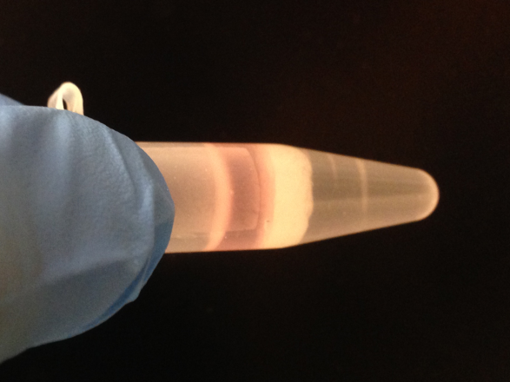

Middle fluffy layer (Exosome is in this layer.)

Bottom colorless layer

1. Pipet out the Top transparent layer and discard it. Insert pipette tip down to the tube bottom to completely remove the Bottom colorless layer and discard it. Only keep the Middle fluffy layer in the tube. Exosome is in this layer.

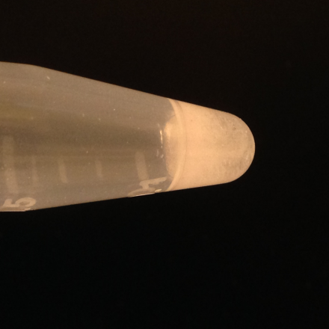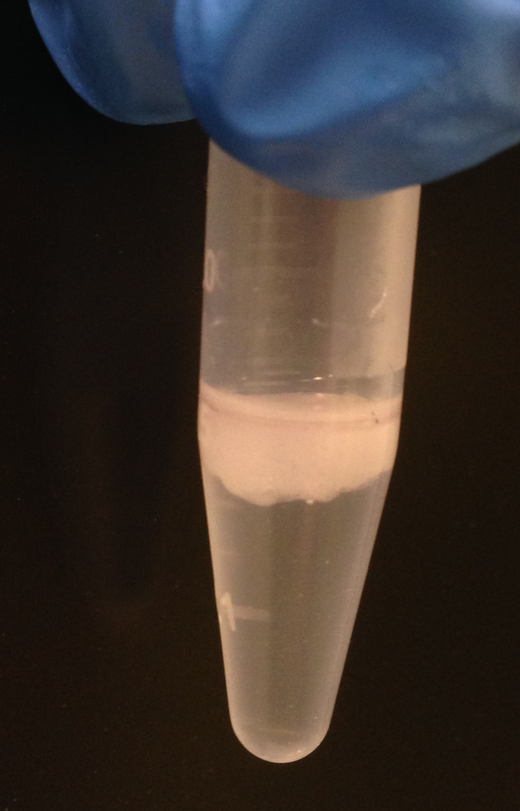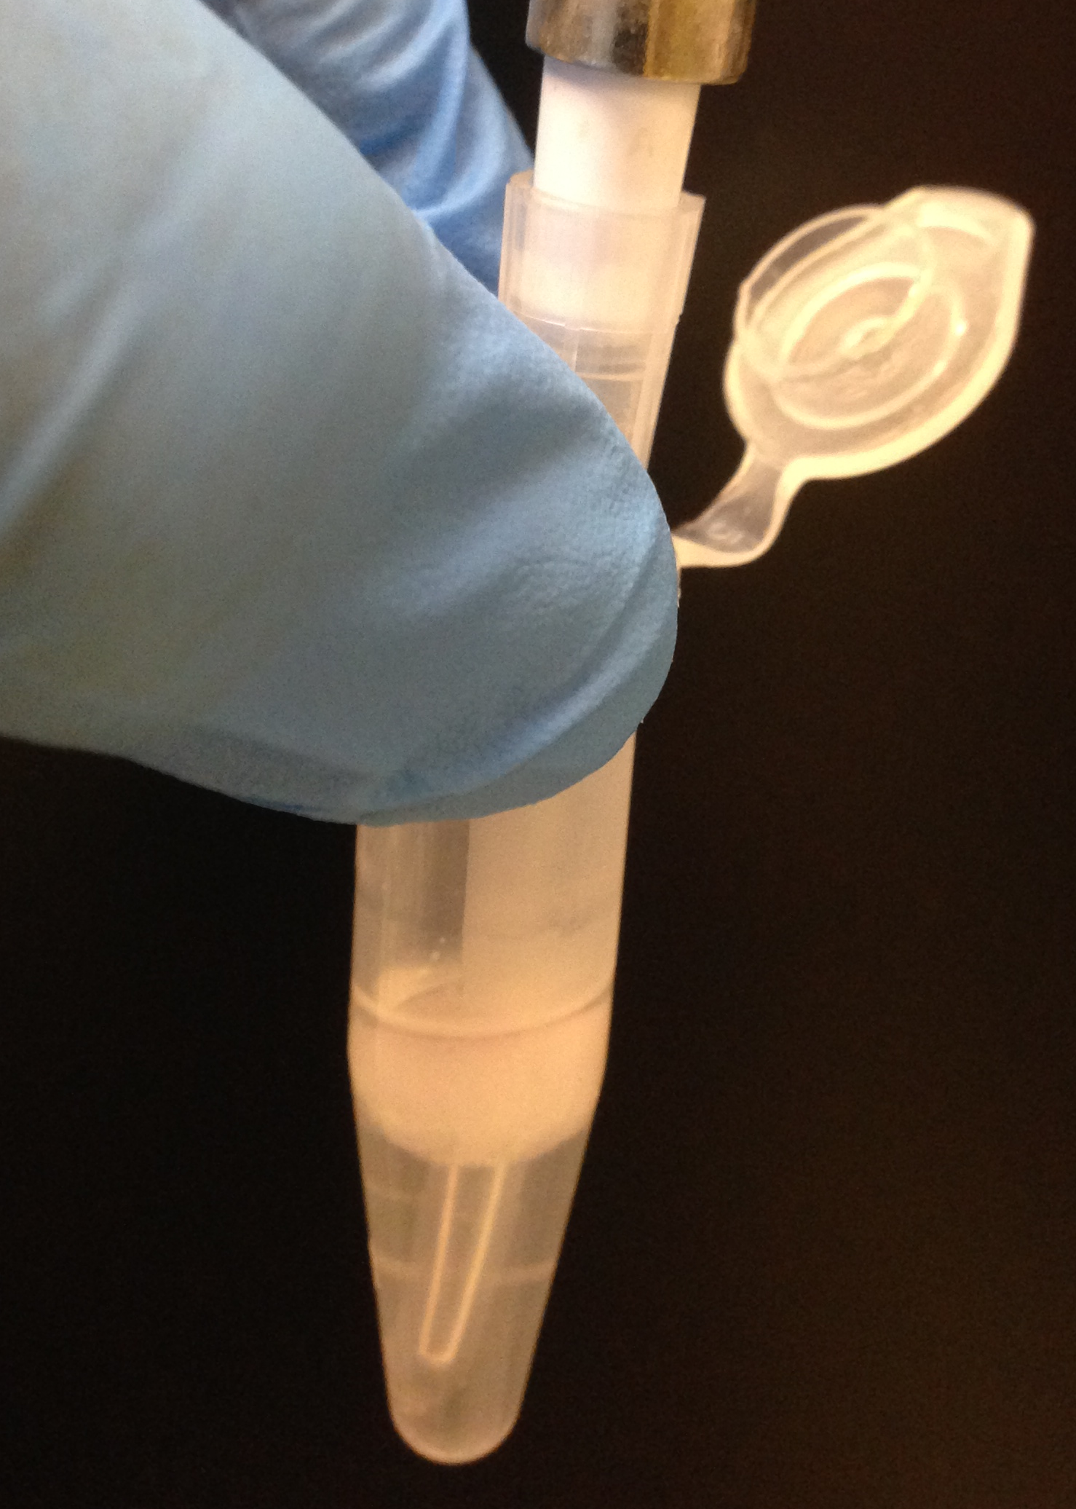

**only keep the Middle fluffy layer**

Pipet out the Top transparent layer

Remove the Bottom colorless layer

1. Spin again at **5,000x g for 3 minutes,** and 3 layers will appear again. Now, repeat **step 11** for one more time**.** Now only the **“fluff pellet”** left in the tube. The **“fluff pellet”** volume is about 25 µL in this example experiment.
2. Leave the tube cap open to **air dry** for 5-10 minutes at room temp (do not over dry).
3. Add **1× PBS** equal to **4 times volumes** of the collected fluff pellet to the tube. in this example experiment, we added 100 µL PBS (4 x 25 µL fluff pellet). Resuspend the fluff pellet by pipetting up and down **vigorously for 40 times**.
4. Shake the tube on a horizontal shaker at high speed for **3 minutes**, then **pipet up and down vigorously** for 10 times. Repeat this “shake-pipet up and down” for another 2 times.

**Note:** This step is important. If the fluff pellet is not well re-suspended, the exosome may be trapped in the fluff pellet resulting in low exosome purity and yield. For some types of samples, eg. Hyperlipidemia patient serum sample, it is difficult to dissociate the fluff pellet to release exosome. In such case, extend the pipetting and shaking time in this step.

1. Spin the tube at **5,000x g** for **5 minutes**. Without disturbing the “fluff pellet”, transfer the **supernatant** carefully into one **PureExo**® **Column** (provided).

**Note:** Keep the “fluff pellet” at 4oC. Do not discard it until the experiment is finished. See “Trouble shooting” 1.2 for detail.

1. Spin the PureExo® Column at **3,000× g** for **5 minutes** to collect the “flow-through”.
2. The “flow-through” is the **isolated pure exosome** (exosome suspended in PBS). The whole protocol is **completed** here. Use it directly for downstream assays (e.g. use 101Bio *Exosomal RNA and Protein Extraction Kit, Cat.#: P200,* to extract exosomal RNA/Protein), or store at 4°C for up to 1 week , or at −80°C for up to 3 months. Concentrated exosome will precipitate after sitting. Pipet up and down to resuspend it well before each use.

**Trouble shouting**

1. **The final exosome yield is low.**
   1. Check if there are left over liquid in the column. If yes, it indicates the column is clogged by contaminated protein. Several reasons could cause the clogging, such as debris was not removed completely in step 2; too much lipid protein in the sample (eg. Hyperlipidemia); some precipitation was pipet up in step 16; too much sample was loaded, etc. If this clogging happens, prepare the sample again, input lower amount of sample, and pay more attention in step 2 and 16.
   2. For some types of samples, it is difficult to re-suspend the fluff (in step 15), and the exosome may be trapped in the fluff. Add the final flow-through back to the fluff pellet stored in 4oC (in step 14, a lot of exosomes are trapped in the fluff), pipet up and down **vigorously for 60 times**, and shake the tube on a horizontal shaker for **20 minutes**. **Repeat pipetting** up and down vigorously a few times during the shaking. Go through another column to collect the exosomes.
   3. For some sample type, the content of exosome is low (the middle fluff layer is thin in step 9). Increase the initial input sample volume to collect more exosome.
2. **The flow through has multiple layers.**

There was bottom and/or top layer left in the fluff during step 11-12. Spin the tube at **5,000× g** for **3 minutes**, and carefully pipet out the bottom layer. Pass the sample through a new column to collect the flow-though.

1. **Exosome yield is good, but exosomal protein level is low.**

Exosome membrane is more difficult to be lysed than cells. Normal lysis buffer for cells, such as RIPA, is not strong enough to completely lysis exosome to release exosomal protein. We suggest to use our Exosomal RNA and Protein Extraction Kit (Cat.#: P200) to extract exosomal protein.

1. **Exosome yield is good, but exosomal RNA level is low.**
   1. RNA degradation. Please check the working environment for RNase free. Also can add spike-in RNA to isolated exosome and then do RNA isolation to control the RNA extraction procedure.
   2. We suggest to use our P200 kit to extract exosomal RNA.
2. **Exosomal RNA yield is good, but cannot get RT-PCR amplification.**
   1. Please check internal control amplification.
   2. Please check the primer sensitivity.

**Customer also buy:**

|  |  |  |
| --- | --- | --- |
| **DNA Extraction / PCR** | Cat. # | **Feature** |
| 1-Drop PCR Mix (squeeze 1 drop do PCR, no pipetting) | W2599-5 | squeeze bottle makes PCR easier |
| Plasmid Miniprep | W0500-50 | 40 % below market price |
| Endotoxin-Free Plasmid Maxiprep | W2104-10 | 40 % below market price |
| Plasmid 96 Miniprep (4 x 96 rxn) | W0506-496 | 50 % below market price |
| 2x Gold Master Mix (with dyes, hot start, HiFi) | W0655-5 | 25 % below market price |